POWER SUPPLY LABEL AND PLUG PINOUT FOR THE MICRO-PERIPHERALS/SINCLAIR DISK INTERFACE PLUS PICTURES OF THE SYSTEM
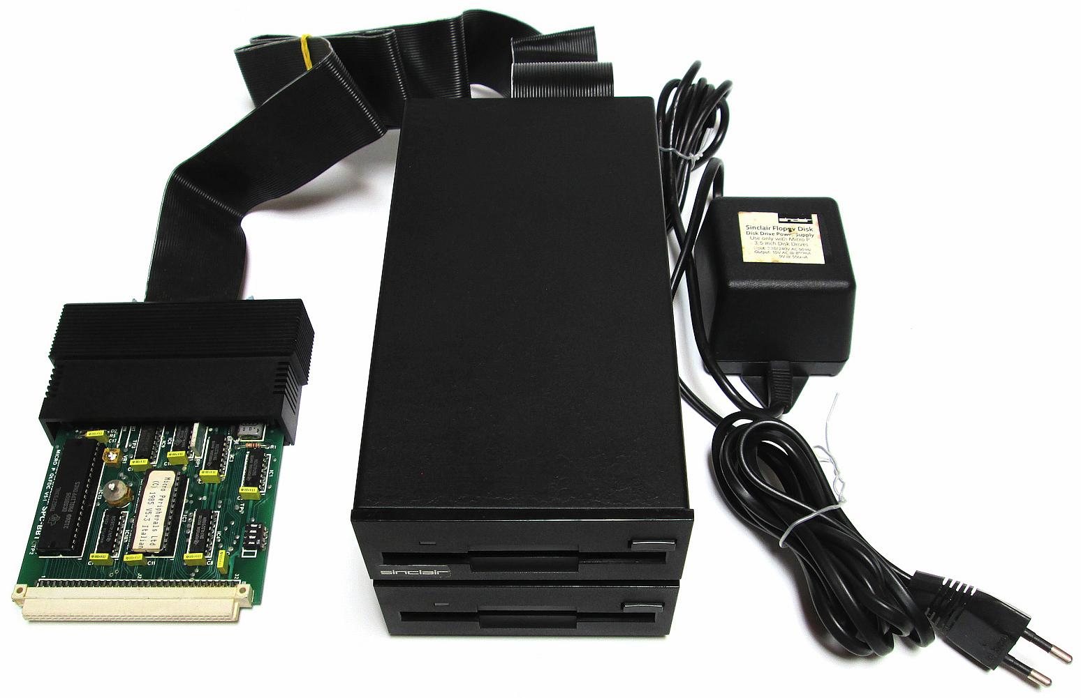
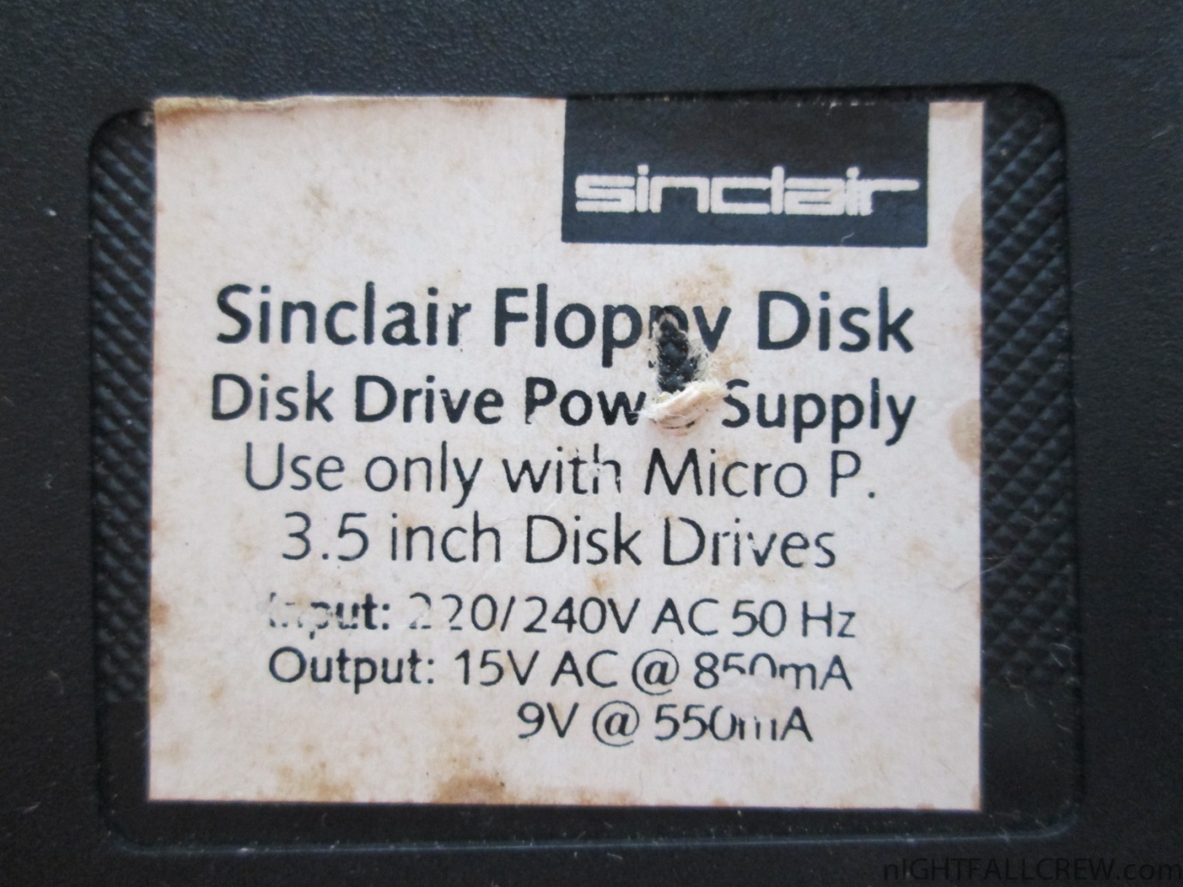


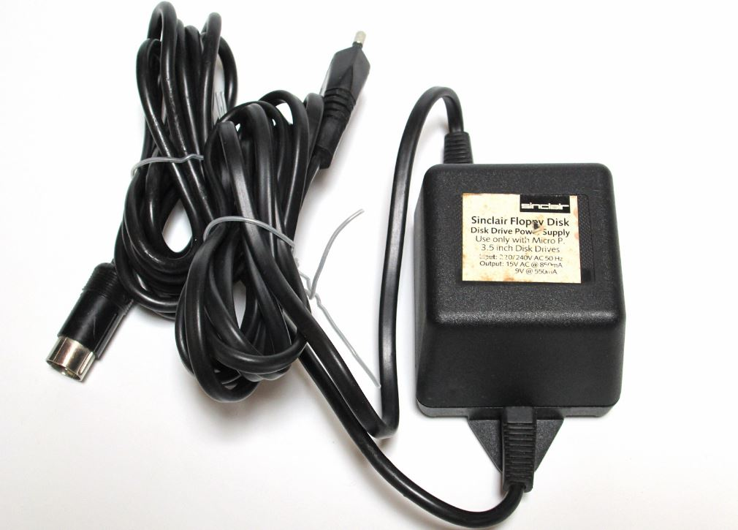
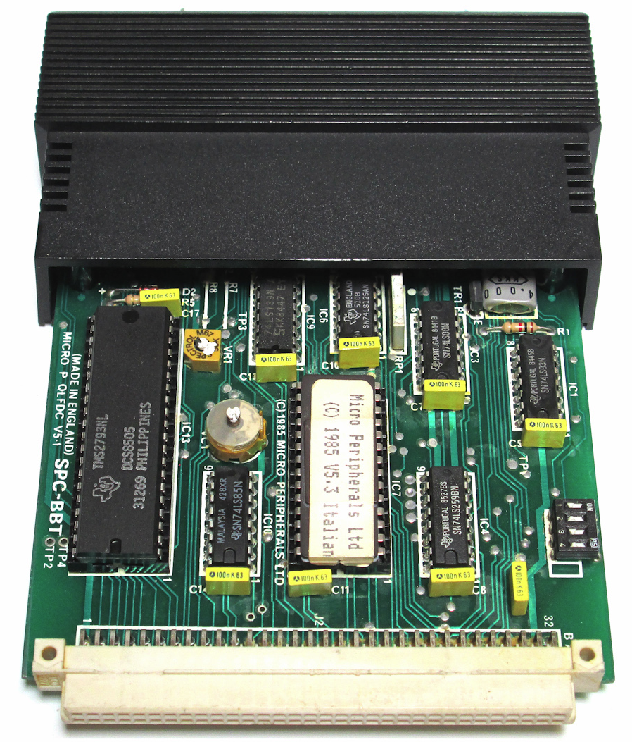

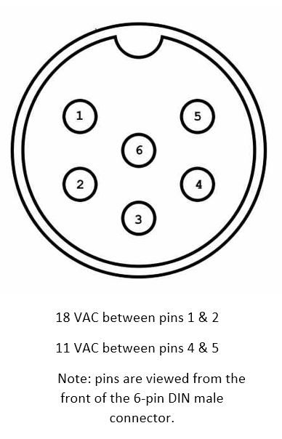
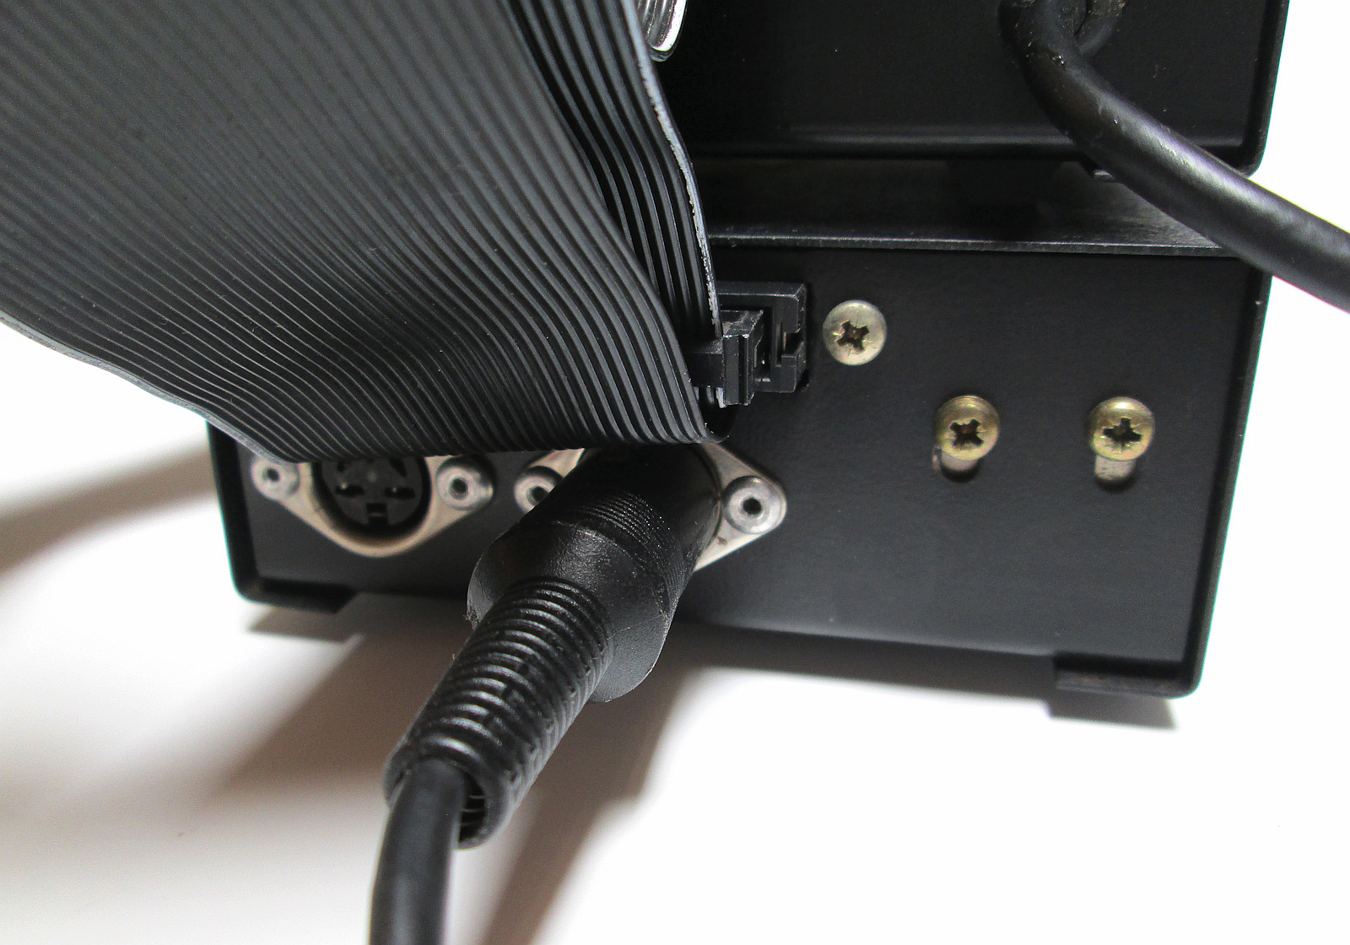

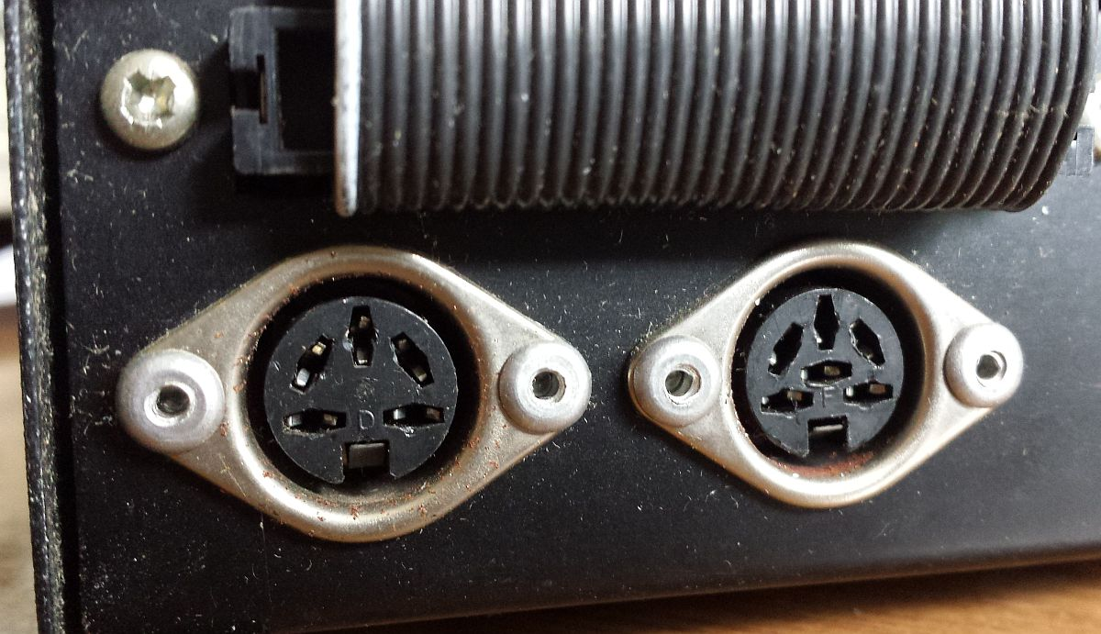
The power connectors on the first MicroPeripherals disk drive – the power supply connects to the 6-pin connector (right) and the second floppy disk drive connects to the five pin (left) connector.

