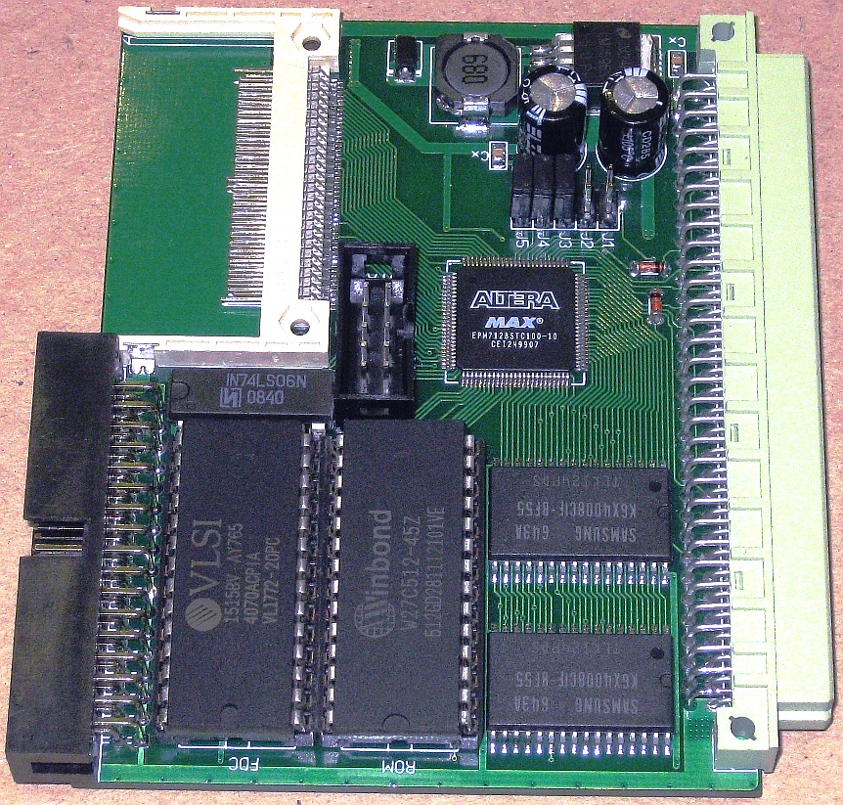
Prototype of Tetroid’s new Trump Card with Qubide clone and Compact Flash
January 2017
Sunday | Monday | Tuesday | Wednesday | Thursday | Friday | Saturday
1 | 2 | 3 | 4 | 5 | 6 | 7
8 | 9 | 10 | 11 | 12 | 13 | 14
15 | 16 | 17 | 18 | 19 | 20 | 21
22 | 23 | 24 | 25 | 26 | 27 | 28
29 | 30 | 31
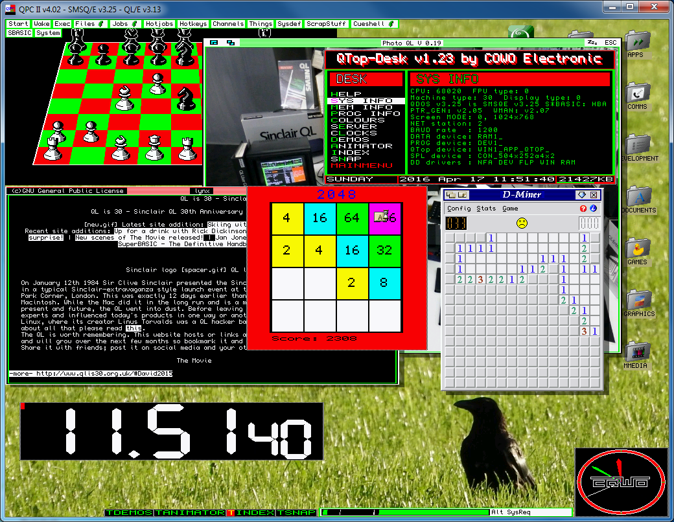
QL/E, The virtual QL environment from COWO Electronic
February 2017
Sunday | Monday | Tuesday | Wednesday | Thursday | Friday | Saturday
 |  |  | 1 | 2 | 3 | 4
5 | 6 | 7 | 8 | 9 | 10 | 11
12 | 13 | 14 | 15 | 16 | 17 | 18
19 | 20 | 21 | 22 | 23 | 24 | 25
26 | 27 | 28
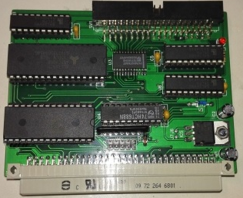
Zaxon’s Qubide clone with 512K RAM
March 2017
Sunday | Monday | Tuesday | Wednesday | Thursday | Friday | Saturday
 |  |  | 1 | 2 | 3 | 4
5 | 6 | 7 | 8 | 9 | 10 | 11
12 | 13 | 14 | 15 | 16 | 17 | 18
19 | 20 | 21 | 22 | 23 | 24 | 25
26 | 27 | 28 | 29 | 30 | 31
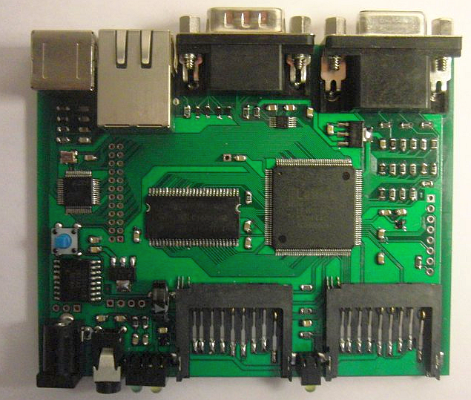
Q68 prototype circuit board
April 2017
Sunday | Monday | Tuesday | Wednesday | Thursday | Friday | Saturday
 |  |  |  |  |  | 1
2 | 3 | 4 | 5 | 6 | 7 | 8
9 | 10 | 11 | 12 | 13 | 14 | 15
16 | 17 | 18 | 19 | 20 | 21 | 22
23 | 24 | 25 | 26 | 27 | 28 | 29
30
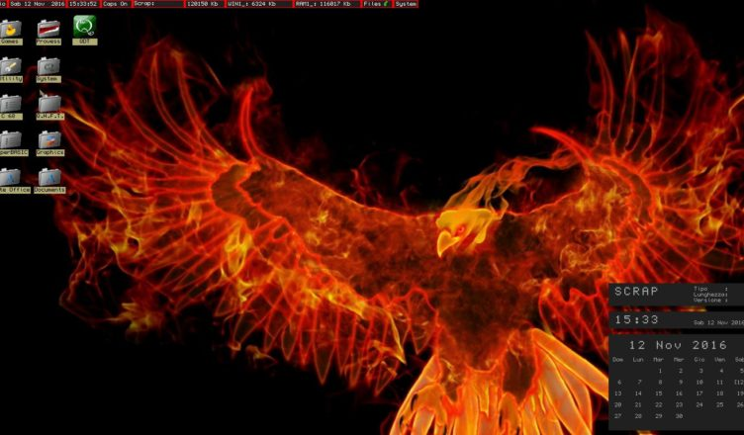
Black Phoenix software compilation from Giorgio Garabello
May 2017
Sunday | Monday | Tuesday | Wednesday | Thursday | Friday | Saturday
 | 1 | 2 | 3 | 4 | 5 | 6
7 | 8 | 9 | 10 | 11 | 12 | 13
14 | 15 | 16 | 17 | 18 | 19 | 20
21 | 22 | 23 | 24 | 25 | 26 | 27
28 | 29 | 30 | 31

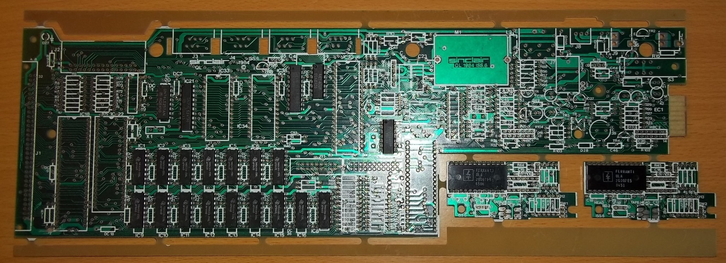
Sinclair QL circuit board
June 2017
Sunday | Monday | Tuesday | Wednesday | Thursday | Friday | Saturday
 |  |  |  | 1 | 2 | 3
4 | 5 | 6 | 7 | 8 | 9 | 10
11 | 12 | 13 | 14 | 15 | 16 | 17
18 | 19 | 20 | 21 | 22 | 23 | 24
25 | 26 | 27 | 28 | 29 | 30
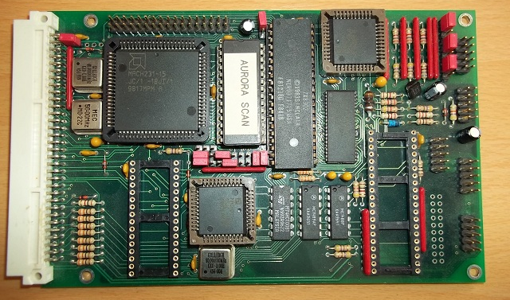
Aurora circuit board
July 2017
Sunday | Monday | Tuesday | Wednesday | Thursday | Friday | Saturday
 |  |  |  |  |  | 1
2 | 3 | 4 | 5 | 6 | 7 | 8
9 | 10 | 11 | 12 | 13 | 14 | 15
16 | 17 | 18 | 19 | 20 | 21 | 22
23 | 24 | 25 | 26 | 27 | 28 | 29
30 | 31
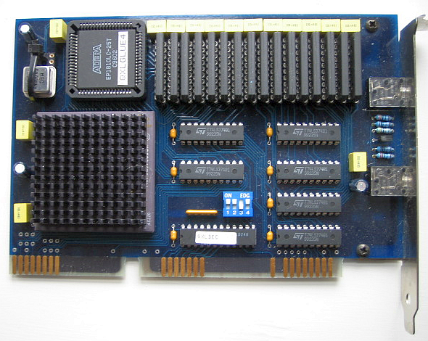
A QXL card
August 2017
Sunday | Monday | Tuesday | Wednesday | Thursday | Friday | Saturday
 |  | 1 | 2 | 3 | 4 | 5
6 | 7 | 8 | 9 | 10 | 11 | 12
13 | 14 | 15 | 16 | 17 | 18 | 19
20 | 21 | 22 | 23 | 24 | 25 | 26
27 | 28 | 29 | 30 | 31
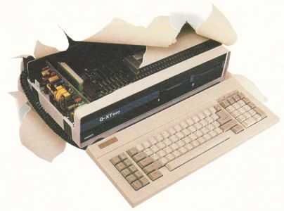
A Sandy QXT-640
September 2017
Sunday | Monday | Tuesday | Wednesday | Thursday | Friday | Saturday
 |  |  |  |  | 1 | 2
3 | 4 | 5 | 6 | 7 | 8 | 9
10 | 11 | 12 | 13 | 14 | 15 | 16
17 | 18 | 19 | 20 | 21 | 22 | 23
24 | 25 | 26 | 27 | 28 | 29 | 30
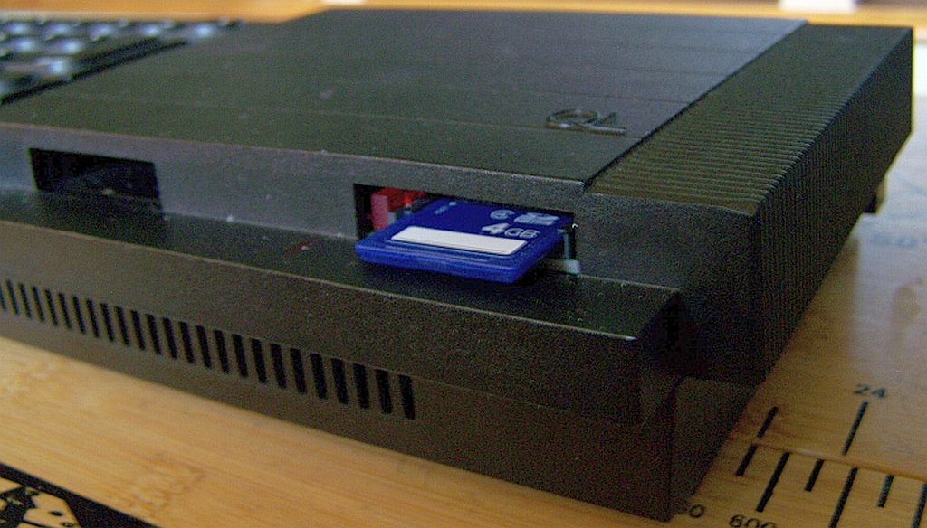
A QL-SD installed in the MDV2 slot
October 2017
Sunday | Monday | Tuesday | Wednesday | Thursday | Friday | Saturday
1 | 2 | 3 | 4 | 5 | 6 | 7
8 | 9 | 10 | 11 | 12 | 13 | 14
15 | 16 | 17 | 18 | 19 | 20 | 21
22 | 23 | 24 | 25 | 26 | 27 | 28
29 | 30 | 31
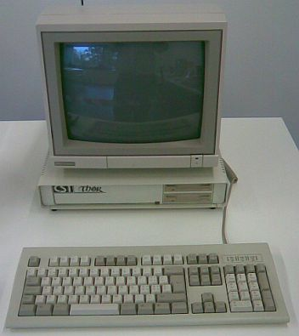
A CST Thor computer
November 2017
Sunday | Monday | Tuesday | Wednesday | Thursday | Friday | Saturday
 |  |  | 1 | 2 | 3 | 4
5 | 6 | 7 | 8 | 9 | 10 | 11
12 | 13 | 14 | 15 | 16 | 17 | 18
19 | 20 | 21 | 22 | 23 | 24 | 25
26 | 27 | 28 | 29 | 30
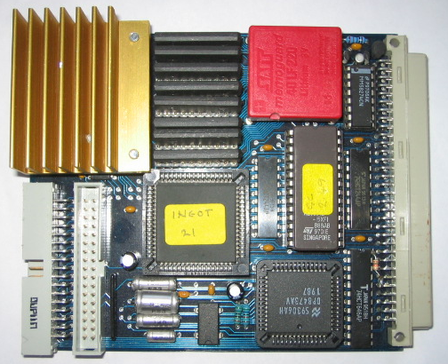
A Super Gold Card
December 2017
Sunday | Monday | Tuesday | Wednesday | Thursday | Friday | Saturday
 |  |  |  |  | 1 | 2
3 | 4 | 5 | 6 | 7 | 8 | 9
10 | 11 | 12 | 13 | 14 | 15 | 16
17 | 18 | 19 | 20 | 21 | 22 | 23
24 | 25 | 26 | 27 | 28 | 29 | 30
31

