January |  |  |  | 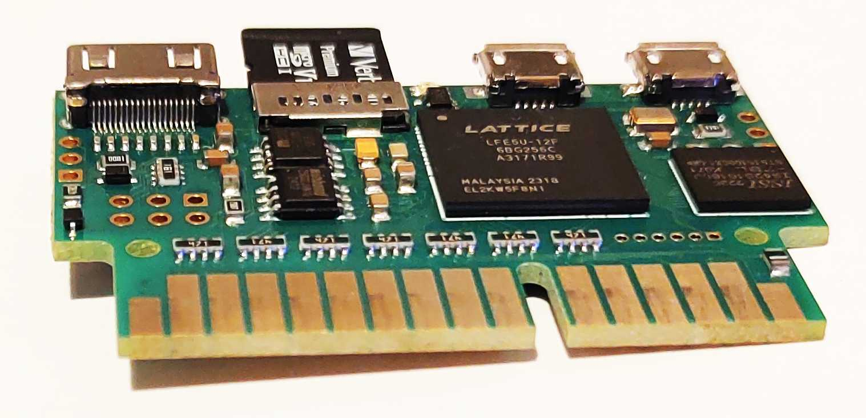
Sinclair QL |  |  |  | 2025
Sunday | Monday | Tuesday | Wednesday |  | Thursday | Friday | Saturday
 |  |  | 1 |  | 2 | 3 | 4
5 | 6 | 7 | 8 |  | 9 | 10 | 11
12 | 13 | 14 | 15 |  | 16 | 17 | 18
19 | 20 | 21 | 22 |  | 23 | 24 | 25
26 | 27 | 28 | 29 |  | 30 | 31

February |  |  |  | 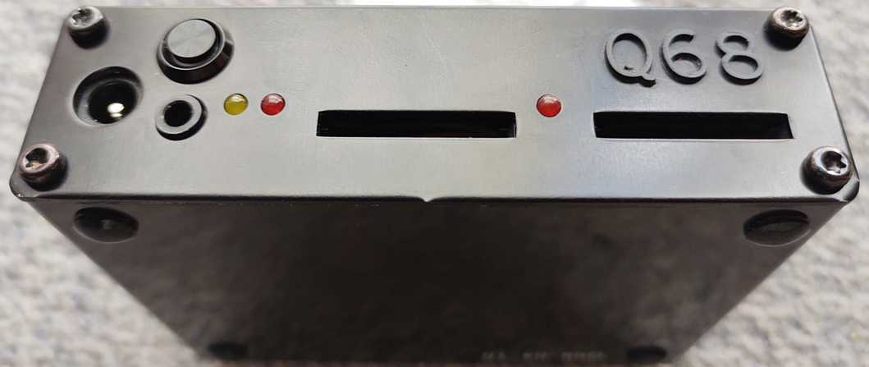
Sinclair QL |  |  |  | 2025
Sunday | Monday | Tuesday | Wednesday |  | Thursday | Friday | Saturday
 |  |  |  |  |  |  | 1
2 | 3 | 4 | 5 |  | 6 | 7 | 8
9 | 10 | 11 | 12 |  | 13 | 14 | 15
16 | 17 | 18 | 19 |  | 20 | 21 | 22
23 | 24 | 25 | 26 |  | 27 | 28
March |  |  |  | 
Sinclair QL |  |  |  | 2025
Sunday | Monday | Tuesday | Wednesday |  | Thursday | Friday | Saturday
 |  |  |  |  |  |  | 1
2 | 3 | 4 | 5 |  | 6 | 7 | 8
9 | 10 | 11 | 12 |  | 13 | 14 | 15
16 | 17 | 18 | 19 |  | 20 | 21 | 22
23 | 24 | 25 | 26 |  | 27 | 28 | 29
30 | 31

April |  |  |  | 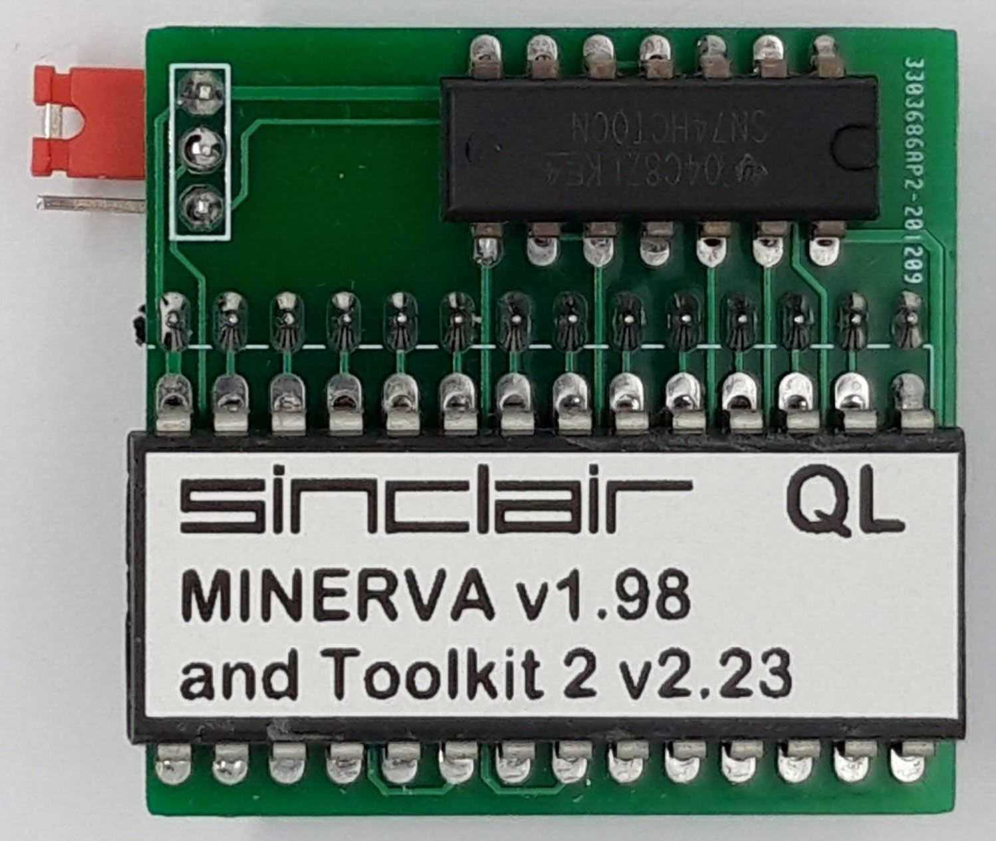
Sinclair QL |  |  |  | 2025
Sunday | Monday | Tuesday | Wednesday |  | Thursday | Friday | Saturday
 |  | 1 | 2 |  | 3 | 4 | 5
6 | 7 | 8 | 9 |  | 10 | 11 | 12
13 | 14 | 15 | 16 |  | 17 | 18 | 19
20 | 21 | 22 | 23 |  | 24 | 25 | 26
27 | 28 | 29 | 30

May |  |  | 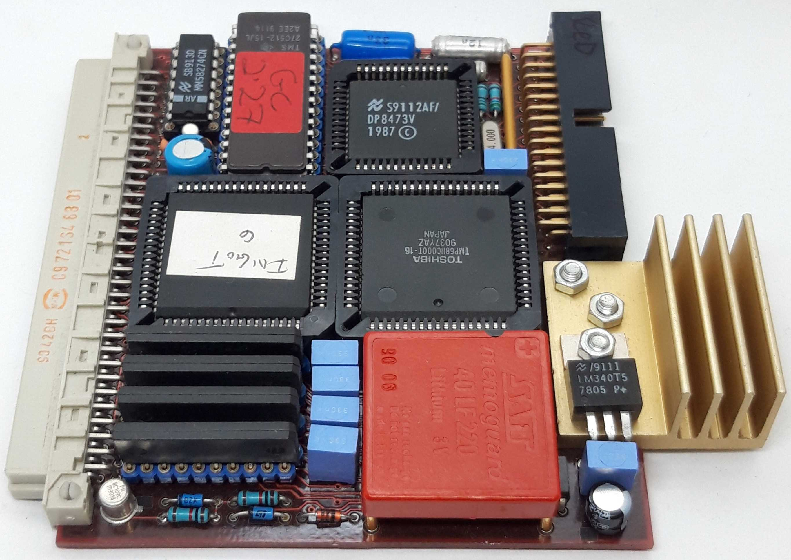
Sinclair QL |  |  | 2025
Sunday | Monday | Tuesday | Wednesday | Thursday | Friday | Saturday
 |  |  |  | 1 | 2 | 3
4 | 5 | 6 | 7 | 8 | 9 | 10
11 | 12 | 13 | 14 | 15 | 16 | 17
18 | 19 | 20 | 21 | 22 | 23 | 24
25 | 26 | 27 | 28 | 29 | 30 | 31

June |  |  |  | 
Sinclair QL |  |  |  | 2025
Sunday | Monday | Tuesday | Wednesday |  | Thursday | Friday | Saturday
1 | 2 | 3 | 4 |  | 5 | 6 | 7
8 | 9 | 10 | 11 |  | 12 | 13 | 14
15 | 16 | 17 | 18 |  | 19 | 20 | 21
22 | 23 | 24 | 25 |  | 26 | 27 | 28
29 | 30

July |  |  |  | 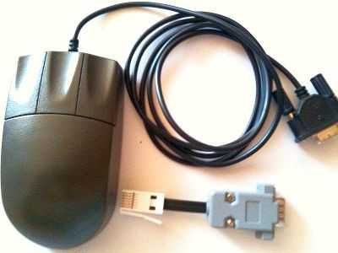
Sinclair QL |  |  |  | 2025
Sunday | Monday | Tuesday | Wednesday |  | Thursday | Friday | Saturday
 |  | 1 | 2 |  | 3 | 4 | 5
6 | 7 | 8 | 9 |  | 10 | 11 | 12
13 | 14 | 15 | 16 |  | 17 | 18 | 19
20 | 21 | 22 | 23 |  | 24 | 25 | 26
27 | 28 | 29 | 30 |  | 31

August |  |  |  | 
Sinclair QL |  |  |  | 2025
Sunday | Monday | Tuesday | Wednesday |  | Thursday | Friday | Saturday
 |  |  |  |  |  | 1 | 2
3 | 4 | 5 | 6 |  | 7 | 8 | 9
10 | 11 | 12 | 13 |  | 14 | 15 | 16
17 | 18 | 19 | 20 |  | 21 | 22 | 23
24 | 25 | 26 | 27 |  | 28 | 29 | 30
31

September |  |  |  | 
Sinclair QL |  |  |  | 2025
Sunday | Monday | Tuesday | Wednesday |  | Thursday | Friday | Saturday
 | 1 | 2 | 3 |  | 4 | 5 | 6
7 | 8 | 9 | 10 |  | 11 | 12 | 13
14 | 15 | 16 | 17 |  | 18 | 19 | 20
21 | 22 | 23 | 24 |  | 25 | 26 | 27
28 | 29 | 30

October |  |  |  | 
Sinclair QL |  |  |  | 2025
Sunday | Monday | Tuesday | Wednesday |  | Thursday | Friday | Saturday
 |  |  | 1 |  | 2 | 3 | 4
5 | 6 | 7 | 8 |  | 9 | 10 | 11
12 | 13 | 14 | 15 |  | 16 | 17 | 18
19 | 20 | 21 | 22 |  | 23 | 24 | 25
26 | 27 | 28 | 29 |  | 30 | 31

November |  |  |  | 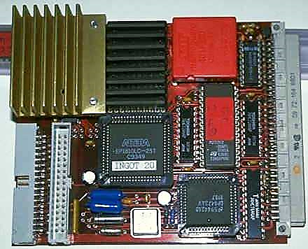
Sinclair QL |  |  |  | 2025
Sunday | Monday | Tuesday | Wednesday |  | Thursday | Friday | Saturday
 |  |  |  |  |  |  | 1
2 | 3 | 4 | 5 |  | 6 | 7 | 8
9 | 10 | 11 | 12 |  | 13 | 14 | 15
16 | 17 | 18 | 19 |  | 20 | 21 | 22
23 | 24 | 25 | 26 |  | 27 | 28 | 29
30

December |  |  |  | 
Sinclair QL |  |  |  | 2025
Sunday | Monday | Tuesday | Wednesday |  | Thursday | Friday | Saturday
 | 1 | 2 | 3 |  | 4 | 5 | 6
7 | 8 | 9 | 10 |  | 11 | 12 | 13
14 | 15 | 16 | 17 |  | 18 | 19 | 20
21 | 22 | 23 | 24 |  | 25 | 26 | 27
28 | 29 | 30 | 31

