
January 2013
sinclair QL
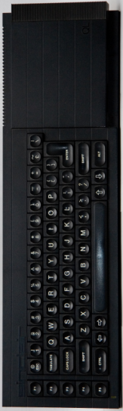
Sunday | Monday | Tuesday | Wednesday | Thursday | Friday | Saturday
 |  | 1 | 2 | 3 | 4 | 5
6 | 7 | 8 | 9 | 10 | 11 | 12
13 | 14 | 15 | 16 | 17 | 18 | 19
20 | 21 | 22 | 23 | 24 | 25 | 26
27 | 28 | 29 | 30 | 31
sinclair QL
February 2013
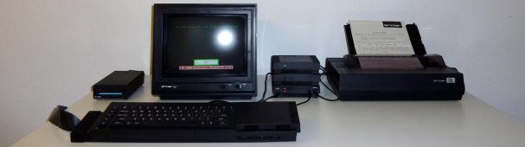
Sunday | Monday | Tuesday | Wednesday | Thursday | Friday | Saturday
 |  |  |  |  | 1 | 2
3 | 4 | 5 | 6 | 7 | 8 | 9
10 | 11 | 12 | 13 | 14 | 15 | 16
17 | 18 | 19 | 20 | 21 | 22 | 23
24 | 25 | 26 | 27 | 28
sinclair QL
March 2013
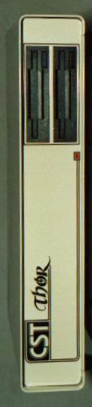
Sunday | Monday | Tuesday | Wednesday | Thursday | Friday | Saturday
 |  |  |  |  | 1 | 2
3 | 4 | 5 | 6 | 7 | 8 | 9
10 | 11 | 12 | 13 | 14 | 15 | 16
17 | 18 | 19 | 20 | 21 | 22 | 23
24 | 25 | 26 | 27 | 28 | 29 | 30
31
sinclair QL
April 2013
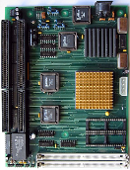
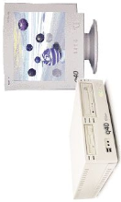
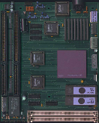
Sunday | Monday | Tuesday | Wednesday | Thursday | Friday | Saturday
 | 1 | 2 | 3 | 4 | 5 | 6
7 | 8 | 9 | 10 | 11 | 12 | 13
14 | 15 | 16 | 17 | 18 | 19 | 20
21 | 22 | 23 | 24 | 25 | 26 | 27
28 | 29 | 30
sinclair QL
May 2013
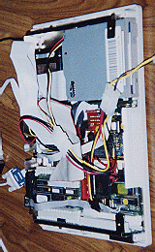
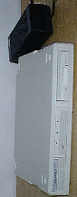
Sunday | Monday | Tuesday | Wednesday | Thursday | Friday | Saturday
 |  |  | 1 | 2 | 3 | 4
5 | 6 | 7 | 8 | 9 | 10 | 11
12 | 13 | 14 | 15 | 16 | 17 | 18
19 | 20 | 21 | 22 | 23 | 24 | 25
26 | 27 | 28 | 29 | 30 | 31
sinclair QL
June 2013
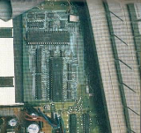
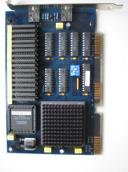
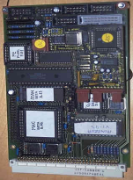
Sunday | Monday | Tuesday | Wednesday | Thursday | Friday | Saturday
 |  |  |  |  |  | 1
2 | 3 | 4 | 5 | 6 | 7 | 8
9 | 10 | 11 | 12 | 13 | 14 | 15
16 | 17 | 18 | 19 | 20 | 21 | 22
23 | 24 | 25 | 26 | 27 | 28 | 29
30
sinclair QL
July 2013
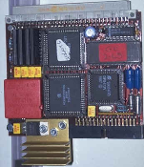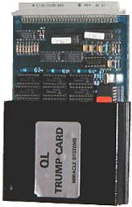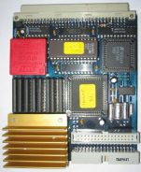
Sunday | Monday | Tuesday | Wednesday | Thursday | Friday | Saturday
 | 1 | 2 | 3 | 4 | 5 | 6
7 | 8 | 9 | 10 | 11 | 12 | 13
14 | 15 | 16 | 17 | 18 | 19 | 20
21 | 22 | 23 | 24 | 25 | 26 | 27
28 | 29 | 30 | 31
sinclair QL
August 2013

Sunday | Monday | Tuesday | Wednesday | Thursday | Friday | Saturday
 |  |  |  | 1 | 2 | 3
4 | 5 | 6 | 7 | 8 | 9 | 10
11 | 12 | 13 | 14 | 15 | 16 | 17
18 | 19 | 20 | 21 | 22 | 23 | 24
25 | 26 | 27 | 28 | 29 | 30 | 31
sinclair QL
September 2013



Sunday | Monday | Tuesday | Wednesday | Thursday | Friday | Saturday
1 | 2 | 3 | 4 | 5 | 6 | 7
8 | 9 | 10 | 11 | 12 | 13 | 14
15 | 16 | 17 | 18 | 19 | 20 | 21
22 | 23 | 24 | 25 | 26 | 27 | 28
29 | 30
sinclair QL
October 2013
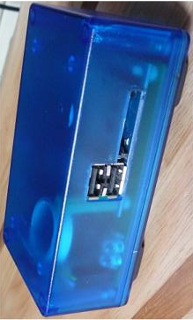

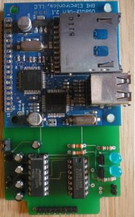
Sunday | Monday | Tuesday | Wednesday | Thursday | Friday | Saturday
 |  | 1 | 2 | 3 | 4 | 5
6 | 7 | 8 | 9 | 10 | 11 | 12
SER-USB
13 | 14 | 15 | 16 | 17 | 18 | 19
20 | 21 | 22 | 23 | 24 | 25 | 26
27 | 28 | 29 | 30 | 31
sinclair QL
November 2013
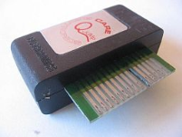

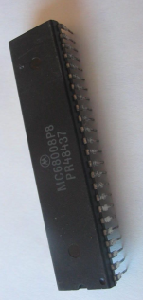
Sunday | Monday | Tuesday | Wednesday | Thursday | Friday | Saturday
 |  |  |  |  | 1 | 2
3 | 4 | 5 | 6 | 7 | 8 | 9
10 | 11 | 12 | 13 | 14 | 15 | 16
17 | 18 | 19 | 20 | 21 | 22 | 23
24 | 25 | 26 | 27 | 28 | 29 | 30
sinclair QL
December 2013
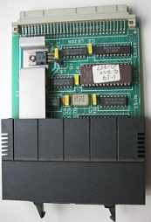
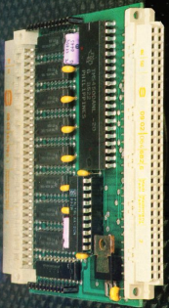
Sunday | Monday | Tuesday | Wednesday | Thursday | Friday | Saturday
1 | 2 | 3 | 4 | 5 | 6 | 7
8 | 9 | 10 | 11 | 12 | 13 | 14
15 | 16 | 17 | 18 | 19 | 20 | 21
22 | 23 | 24 | 25 | 26 | 27 | 28
29 | 30 | 31

