Handle zip files for sinclair QL using "Image Editor" program.
Notes:
- Equiment use in this article: Sinclair QL with JS + TK rom(64K), QubIDE with 512K ram expansion, SD-IDE adpater and 32MB sd memory.
- PC with windows XP
Open and extract programs from sinclair zip files.
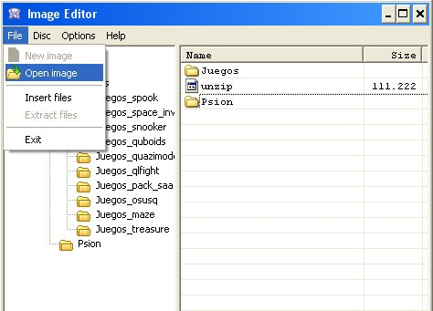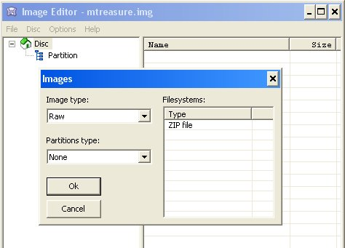
- 1 Start "Image Editor" program. Select "File" > "Open image" menu.
- 2 Select the sinclair QL zip file you want to open.
- 3 The program will detect that zip file is for Sinclair QL. Press "OK" and the program will show the programs inside.zip file.
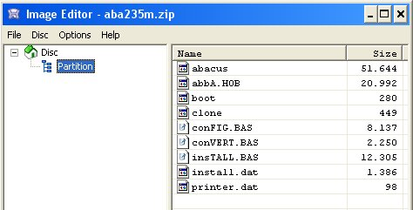
- 4 Now is time to indicate "Image Editor" program that you want to export programs. Like QL header are needed, we'll select "Options" > "Headers" > "QL".
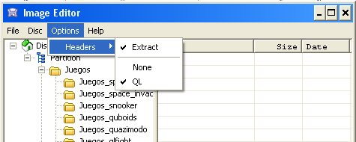
- 5 Use "Files" > "Extract files" menu.
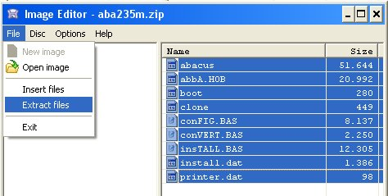
- 6 Select the PC directory where you'll export the programs.
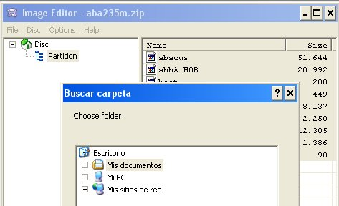
Put programs into your sinclair QL IDE unit.
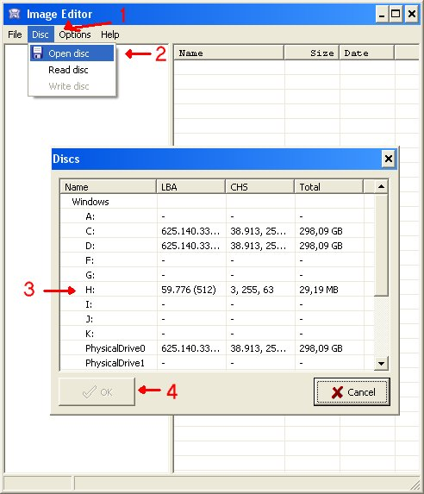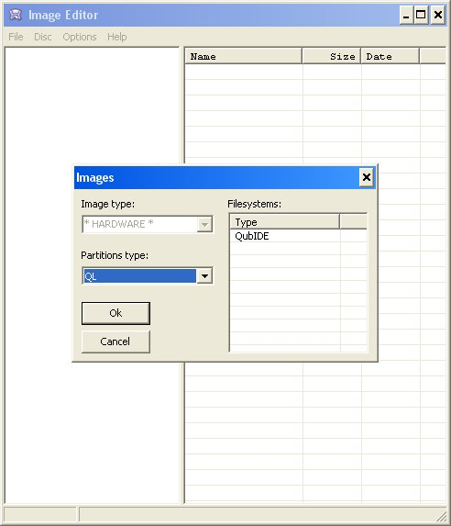
- 1 Open "Image Editor" program and select "Disc" > "Open disc" menu.
- 2 Select your QL IDE unit and press "OK".
- 3 The program will detect that your IDE unit has QubIDE format.
- 4 In order to import programs from PC to QL, indicate "Image Editor" that it makes nothing with QL Headers. "Options" > "Headers" > "None".
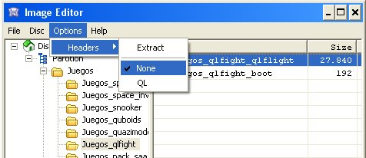
- 5 Use the "File" > "Insert files" menu.
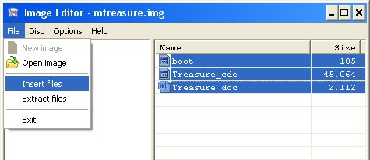
- 6 Select the programs that you want to import. "Image Editor" will automatic change files with "." extension by "_" to avoid problem with standard Sinclair QL. The programs will be inserted in the directory you have selected.
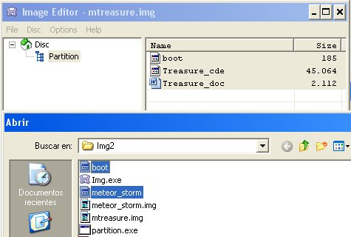
2015 José Leandro Novellón

